The Birthday Interview (Myself)
When is your birthday? __________________________
What are your favorite foods to eat on your birthday? _________________________________________________________________
__________________________________________________________________
__________________________________________________________________
Do you prefer (circle one):
Cake Cupcakes Other: _________________
Where do you go to celebrate your birthday?
_________________________________________________________________
_________________________________________________________________
_________________________________________________________________
What activities do you like to do on your birthday? _________________________________________________________________
Who do you celebrate your birthday with? (mom, dad, friends, siblings, aunts, uncles etc….)
_______________________________________________________________
_______________________________________________________________
_______________________________________________________________
Do you celebrate your birthday the same way every year? (circle one)
YES NO SOMETIMES
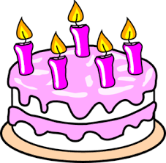

Is your birthday important? Why?
__________________________________________________________
__________________________________________________________
__________________________________________________________
__________________________________________________________

